TC-CSC-026
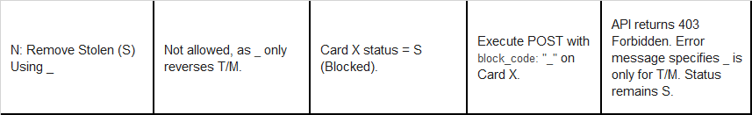
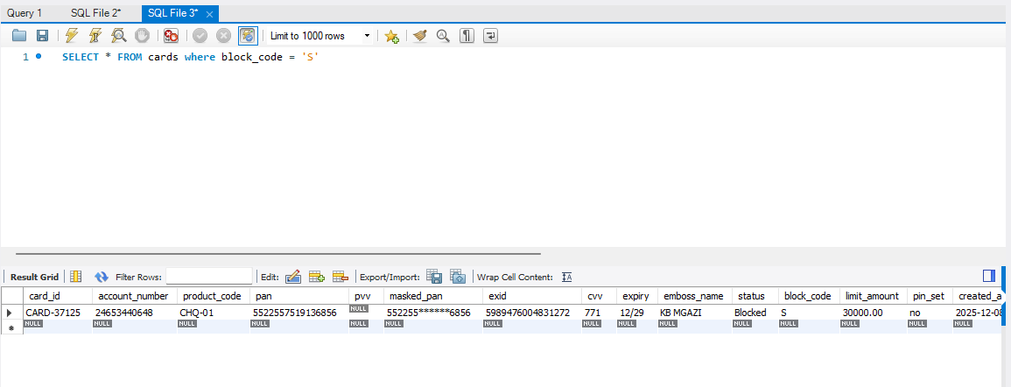
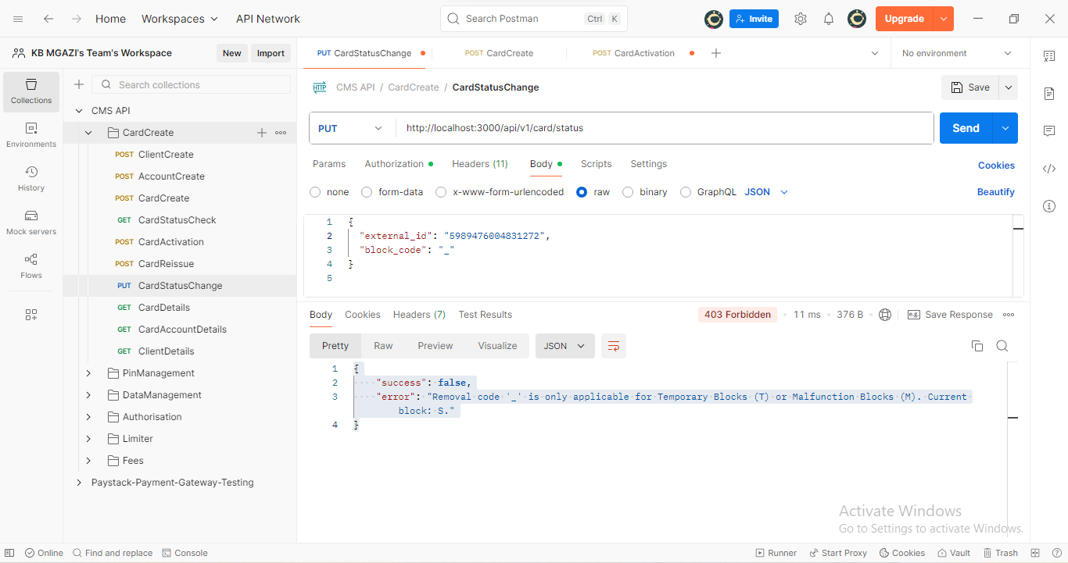
Request:
{
"external_id": "5989476004831272",
"block_code": "_"
}

Response:
{
"success": false,
"error": "Removal code '_' is only applicable for Temporary Blocks (T) or Malfunction Blocks (M). Current block: S."
}
